Unit 5 Compounds Review Worksheet (Test will have the same number and types of problems.)

6 polyatomic ion matching from 6 names from 10 formulas or 6 formulas from 10 names. (1 pt ea)

Complete the table to determine the atomic and ionic Lewis diagrams. (3 pts ea)

|  |  |  |  |  |  |  |
| --- | --- | --- | --- | --- | --- | --- |
|  | Element | # Valence electrons | Atomic Lewis Diagram | # electrons gain/loss | Ionic charge | Ionic Lewis Diagram |
| 7. | **S** | 6 | Related image | Gain 2 | – 2 | Image result for ionic lewis structures |
| 8. | **Al** | 3 | Related image | Lose 3 | +3 | [Al]3+ |

Draw the ionic Lewis structure for the compound that forms between the following elements. (3 pts ea)



I

I

1. Ca and I [Ca]2+ 2



S

2-

1. Ba and S [Ba]2+

Draw the covalent Lewis structure for the covalent compound or polyatomic ion. (3 pts ea)

1. 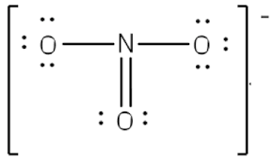 NO3-

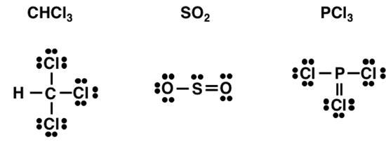

1. SO2

Determine a bond between the two element indicated will be polar, nonpolar or ionic (1 pt ea)

1. H – C nonpolar
2. S – O polar
3. K – Cl ionic

Determine if the following compounds are ionic, covalent or acidic. (1 pt ea)

1. HCl acidic
2. BaO ionic
3. NO2 covalent
4. NH3 covalent

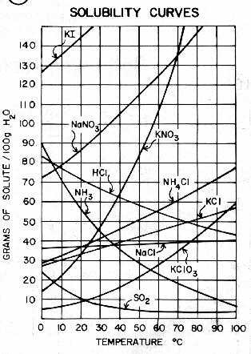20. How many grams of NaNO3 can be dissolve in 100 g of water at 60°C? (1 pt)

124 g

21. To what temperature would you need to heat 100 g of water to dissolve 50.0 grams of KCl? (1 pt)

76ºC

22. How many more grams of KNO3 can you dissolve in 100 g of water at 70°C than at 10°C? (1 pt)

116 g

23. How many grams of ammonia gas, NH3 can be dissolved in 100 g of water at 50°C? (1 pt)

29 g

1. You make a solution of KClO3 by dissolving 5.00 g in 500.00 g of water at 20°C. How many more grams of KClO3 would you need to add to create a saturated solution? (3 pts)

40 g more

1. How many grams of NH4Cl can you dissolve in 50.0 g of water at 70°C? (3 pts)

30 g

For each pair of compounds below, determine the dominant intermolecular force available for each. Then predict which would have the higher melting point. (You could be asked to compare a different property.) (4 pts ea)

1. CH3OCH3 ___Dipole________________ H2O ______Hydrogen bond ____________

Higher melting point: _______H2O____________________

1. CaO_____ionic bonding_____________ NaCl _____ionic bonding_______________

Higher melting point:: ____CaO_______________________

1. SiO2 ____covalent network___________ Fe ______metal boning_________________

Higher melting point:: _______SiO2____________________

**Complete the table below. If a formula is given, provide the name. If the name of the compound is given, provide the formula. (2 pts ea)**

|  |  |
| --- | --- |
| **Name** | **Formula** |
| sulfurous acid | **H2SO3** |
| **chlorine dioxide** | ClO2 |
| hydroiodic acid | **HI** |
| **silver sulfide** | Ag2S |
| sulfur trichloride | **SCl3** |
| **chromic acid** | H2CrO4 |
| calcium iodide | **CaI2** |
| **lithium sulfite** | Li2SO3 |
| chloric acid | **HClO3** |
| **bromous acid** | HBrO2 |
| manganese (IV) oxide | **MnO2** |
| **copper (II) hydroxide** | Cu(OH)2 |
| cobalt (II) carbonate | **CoCO3** |
| **hydrocyanic acid** | HCN |
| ammonia | **NH3** |